Student Recruitment

We aim to cultivate talents. Students interested in advertising, public relations, marketing, cultural creativity and Internet media are welcome to apply.
Timeline
1980 | Mass Communication Department was established
1990 | First institution in Taiwan to run integrated communication courses
1999 | The first Department of Communication to have unified admission for the 1st and 2nd years, with integrated communication courses
2000 | The first School of Communication to engage in exchange with universities in China
2003 | The first School of Communication to offer digital media courses through platforms such as Internet News, Internet Radio, Internet TV, Ming Bao News, MCU Radio Station, MCU TV, Telecommunications & Information Center, Integrated Marketing Communication Center, Cross-Strait Communication Research Center and MCU Academia-Industry Innovation Center
2006 | Mass Communication Program in Overseas Youth Vocational Training School established
2014 | Each Department in the School of Communication began recruiting students individually: Journalism, Radio and TV, Advertising and New Media and Communication Administration
2015 | Department of Advertising renamed as Department of Advertising and Strategic Marketing

銘傳大學116學年度廣告暨策略行銷學系繁星推薦校系分則資料
Ming Chuan University 2027-28 AY
Department of Advertising and Strategic Marketing
High School Star Program Information
Ming Chuan University |  | General Scholastic Ability Test (GSAT) and English Listening Proficiency |  | Order of Items for Entrant Allotment
Department of Advertising and Strategic Marketing  (Taipei Campus) |  |  |  | Order of Items for Entrant Allotment
 |  | Subject | Standard | 1.Academic Score Ranking in Entire Graduating Class of their High School  2. Total GSAT score for Chinese, English and Social Science combined  3. GSAT Chinese Score  4. GSAT English Score  5. Academic Score Ranking in History among entire Graduating Class of their High School  6. GSAT mathematics Score  7. Academic Score Ranking in Civics and Social Science  among entire Graduating Class of their High School
Uni-Dept Code | 04612 | Chinese | --
Uni-Dept Code | 04612 | English | Post-standard
Discipline Type | Type 1 | Mathematics | --
Recruitment Quota | 8 | Social  Science | --
Max No. to Indicate Preference | 38 | Natural Science | --
Max No. to Indicate Preference | 38 | English Listening | --
Additional Quota | 2 | English Listening | --
Max No. to Indicate Preference | 35 | English Listening | --
Notes | 1.Students who enroll through this program (High School Star) may apply for Department transfer in accordance with the relevant regulations.  2.Department of Advertising and Strategic Marketing is the only Department in Taiwan that cultivates talents with cross-disciplinary strategic thinking in Advertising and Strategic Marketing. Students interested in advertising, PR, marketing, creative design, digital media and communication research are welcome to apply for admission.  3.Classes offered on Taipei Campus, please refer to our website at http://web.adv.mcu.edu.tw ; our contact number is 02-28824564-2515
銘傳大學116學年度廣告暨策略行銷學系個人申請校系分則資料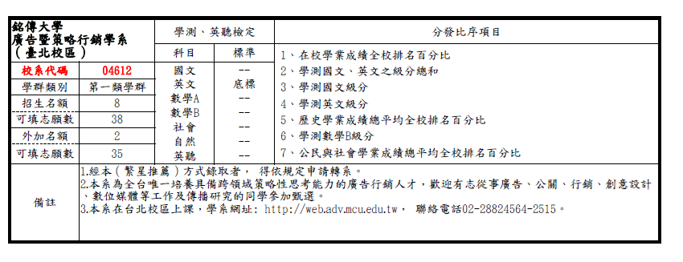
Ming Chuan University 2027-28 AY
Department of Advertising and Strategic Marketing
Individual Application Information
Department of Advertising and Strategic Marketing  (Taipei Campus) |  | General Scholastic Ability Test (GSAT) and English Listening Proficiency Screening Methods |  |  |  | Documentation/Interview Scoring Method and Weighting |  |  |  |  |  |  | Order in which Documentation/Interview Scores will be considered in case of tie in Overall Score
 |  | Stage 1 |  |  |  | Stage 2
 |  | Subject | Minimum | Screening Rate | GSAT score formula |  |  | Weighting in Overall Score | Designated Items | Minimum | Weighting of Documentation / Interview Items
Dept Code | 046132 | Chinese | -- | -- | *2.00 |  |  | 20% | Documentation Review | -- | 35% | 1.Oral Test  2.Documentation Review
Recruitment Quota | 27 | English | Post-standard | -- |  |  |  | 20% | Oral Test | 70分 | 45%
Gender Mix | N/A | MathematicsB | -- |  | *1.50 |  |  | 20%
Est Documentation/ Interviewees | 81 | Chinese,  MathematicsB | -- | 3 | -- |  |  | 20%
Additional Indigenous Peoples’ Students | 3 |  | -- | -- | -- |  |  | 20% |  |  |  | Additional Outlying Island Students Limit
Additional Outlying Island Students | None |  | -- | -- | -- |  |  | 20% |  |  |  | None
Designated Item Fee for Documentaion/ Interviews | 900 |  | -- | -- | -- |  |  | 20%
Send (or announce) Designated Items Notification | March 30, 2027 | Designated Items | Documentation Review |  |  |  | Items: Course record (A), Course Learning Outcome (B,C,E), Versatile performances (F,G,J,M,N), learning history by student (O,P,Q), others (R, other supporting documentation that might be useful for review)  Explanation:  1.Course Learning Outcome (small thesis, learning report, works, activity achievement, special report or reading reports, etc.)  2.Versatile performances: 1. club participation 2. proof of competition results 3. extraordinary performances (special talent certificates or other certificates academically or from other fields that might be useful for review)  3.Learning History Reflection Report (including reflection report, study motivation, learning plan and future career plan)
Deadline for submission | May 05, 2027 | Designated Items
Examination Date for designated items | May 15 to 17, 2027 | Designated Items
Announcement | May 27, 2027 | Designated Items | Examination |  |  |  | 1. Oral test for interview.  2. Please refer to the oral test & Documentation Review of items and standards on Department website （http://web.adv.mcu.edu.tw/）
Deadline for review the total score | May 29, 2027 | Designated Items
Same scores screening methods when quota is exceeded |  | - Total score for GSAT Chinese, English and Mathematics B
Notes |  | 1. Classes offered on Taipei Campus.  2. Department of Advertising and Strategic Marketing is the only department in Taiwan that cultivates talents with cross-disciplinary strategic thinking in Advertising and Strategic Marketing. Students interested in advertising, PR, marketing, creative design, digital media and communication research are welcome to apply for admission.  3. Contact Telephone No.: (02)28824564 Ext. 2515, Fax No.: (02)28809740

銘傳大學116學年度廣銷學系大學個人申請校系分則資料
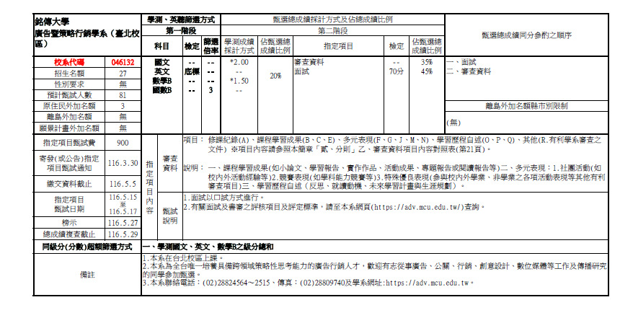

Ming Chuan University - Department of Advertising and Strategic Marketing
2027-28 AY University Entrance Examination Enrollment Information
Item | General Scholastic Ability Test (GSAT) and English Listening Proficiency Standards | Designated Subjects for Entrance Test and Score Weighting Formula |  | Individual Score Used to Break Ties in Total Score | Briefing on Department Selection
Department Required Test | ­­­ | Chinese  (GSAT) | X1.00 | 1 | Interpersonal interaction is required when taking the courses of this department and students will learn about advertising, public relations, creative design and organizing media activities. Visual, hearing, oral expression, and interpersonal communication skills are essential. Classes are offered on Taipei Campus. Department of Advertising and Strategic Marketing is the only department in Taiwan that cultivates talents with cross-disciplinary strategic thinking in Advertising and Strategic Marketing. Students interested in advertising, PR, marketing, creative design, digital media and communication research are welcome to apply for admission. http://web.adv.mcu.edu.tw
Department Required Test | ­­­ | History  (Department Required Test) | X 2.00 | 2
Department Required Test | ­­­ | Civics and Social Science  (Department Required Test) | X 2.00 | 3

銘傳大學116學年度廣銷學系大學分發入學招生資訊資料
項目 | 學科能力測驗及英語聽力測驗檢定標準 | 採計科目  及加權 | 同分參酌 順序 | 選系說明
分科測驗 | ------ | 國文 x1.00(學測) | 1 | 本系學習課程具有與人互動的特性，且需學習 公關、行銷、品牌、創意設計及消費者洞悉。 須備視覺、聽覺判定能力、口語表達及人際互動溝通協調能力、具相當之抗壓能力。在台北 校區上課。為全台唯一培養跨領域策略性思考 能力的廣告行銷人才之科系，歡迎有志廣告、 公關、行銷、品牌及傳播研究的同學就讀。http://web.adv.mcu.edu.tw/
分科測驗 | ------ | 歷史x2.00(分科) | 2
分科測驗 | ------ | 公民與社會x2.00(分科) | 3

發學

